Transport, Accommodation and Fee Arrangements of YSRIM2010

The transport, accommodation and fee arrangements of YSRIM2010 are revised as follows:
Schedule of the conference: February 27~28, 2010 （paper presentation）、March 1, 2010（visiting）
Conference venue: The conference hall of Sino-French Institute of Engineering and Management at Tongji University
Address: No. 1239 Siping Road, Shanghai, China
Accommodation： Days Hotel Tongji Shanghai（standard room: RMB500/day）；4-star hotel
Address：No. 50 Zhangwu Road, Shanghai, China
Tongji University Hotel（standard room: RMB280/天）; 2-star hotel
Address：No. 69 Zhangwu Road, Shanghai, China
Fee of YSRIM2010: 100 US dollars per teacher, 50 US dollars per student
Contact email: ysrim2010@163.com
Technical visiting content: Shanghai Energy Efficiency Center & Shanghai Port International Passenger Transport Center （Participate freely）

Please watch the attachment 1&2 to get the map of YSRIM’2010 and transport method to Tongji University.

YSRIM’2010 Preparatory Group
Tongji University Zhenhai Li

Attachment 1: map of conference venue and accommodation

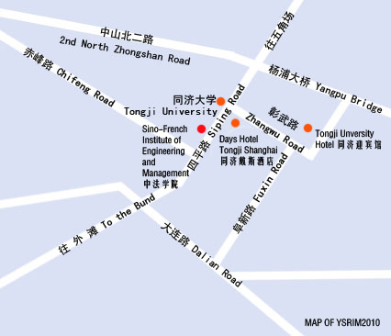

Please show this paper and point the address you want to go to the texi driver if he/she can not understand English:
English: Tongji University; Address: No. 1239 Siping Road, Shanghai, China
Chinese: 同济大学，地址：杨浦区四平路1239号
English：Days Hotel Tongji Shanghai; Address：No. 50 Zhangwu Road, Shanghai, China
Chinese: 同济戴斯酒店，地址：杨浦区彰武路50号同济大学正门口
English: Tongji University Hotel; Address：No. 69 Zhangwu Road, Shanghai, China
Chinese: 同济迎宾馆，地址：杨浦区彰武路69号

Attachment 2: The guide to Sino-French Institute of Engineering and Management

Please follow the map to come to the Sino-French Institute of Engineering and Management when you enter Tongji University form the main entrance (No. 1239 Siping Road)

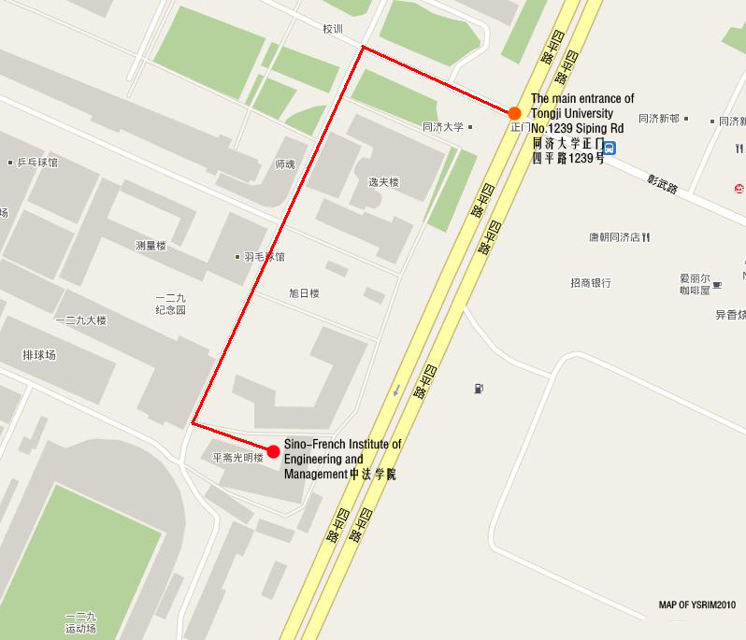

If you need more information about Tongji University, please visit the school web.
Address: http://www.tongji.edu.cn/english/inc/index.asp

